Repent America! Judgment Cometh
April 18th, 2022

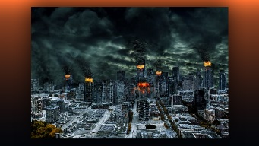
Lord, grant America a repentant heart and turn us away from sin and unrighteous and back to you. Amen.

During the fourth decade of the Divine Mercy Chaplet, I saw Jesus carrying His Cross along the Via Dela Rosa, there were what looked like lifeless, bloody bodies piled up high on either side of Him, as He slowly and deliberately walked towards the place of execution. The Lord would frequently stop before one of the bodies, lean down and lift their chin and whisper something to them and then kiss the top of their heads. After He did this, then the body would be instantly surrounded by hundreds of people all praying in their Heavenly language for the soul. I noticed the bodies that Jesus touched would move ever so slightly and then go still after this large group of people would pray, and this touching and precious scene was repeated over and over again as the Lord made His way toward Calvary.

I felt like Jesus was bringing us deep, deep into His heart, showing us how He feels when we pray for a soul moments before they pass away and they turn to Him in the last seconds of their lives. Some taking their last breath and unable to speak, but in their hearts, they acknowledge that Jesus is their Lord and Savior.

I also could see thousands of bodies didn’t accept Jesus into their hearts, how terrible and devastating to our Lord that these souls still turned away from Him at the hour of their death. You could feel the anguish and heartbreaking pain Jesus was experiencing.

Father Ezekiel also had a vision of a huge soccer stadium in England and there were multitudes of people in the stands, but no players on the field. All of sudden the vast number of people came running down from the stands and rushed the field running from one goal to another, but before they could reach the other field goal they instantly dropped dead.

America’s and the whole world’s chastisement is coming very soon, God’s judgment will fall on us if we do not repent of our sins and turn to Him for forgiveness and His merciful love. If we do not turn from our wicked ways and forgive others, there will be hundreds of thousands of souls destined for hell. Repent, forgive and run into the waiting arms of our Lord Jesus Christ.

Father Ezekiel just pulled a Rhema which said, “Many will be saved though not all, and some will be saved as going through the fire.”

